# ILC at Enfield - Road Transport Coordination Group (RTCG) No37

|  |  |
| --- | --- |
| Date: | Friday, 18 February 2022 |
| Time: | 10:30 -11.30pm |
| Location: | Online – Webex |
| Attendees: | Chair - Steve Cowley (NSW Ports)  Jonathan Lafforgue (NSW Ports)  Jarrad Cayzer (NSW Ports)  Mark Goodall (NSW Ports)  Wayne Ashton (NSW Ports)  Hamish Wood (NSW Ports)  Claudia Martinovic (BSMS Security)  Frank Andriano (LINX)  Geoff DeSantis (Swift Transport)  Gordon Malesevic (Strathfield Council)  Eugene Quigley (Spandex)  Milton Macfarlane (Northside Foods) |
| Apologies: | Dominic Crinnion (DPE) Jason Hwang (ShinMi), Rory Gage (DCE Global), Isabelle Albert (Canterbury Bankstown City), Michael Dicembre (Northside Fine Foods), Paul McFadden (MapeI) |

1. Action Items from Previous Minutes

|  |  |  |  |  |
| --- | --- | --- | --- | --- |
| IteM | responsible  party | Action | Status | COMMENTS |
| 1.1 | Geoff DeSantis | Cars & Trucks stopping outside the takeaway store and concerns that the intersection is not wide enough to allow B-Double & Super B-Doubles to turn safely.  ***Ref – Appendix 1*** | NSWP to supply update at next meeting | NSW Ports to undertake a swept path analysis on the corner of Norfolk and Wentworth St, any solution will likely require Council approval before improvements can be made. |

1. Project Construction Update – MG (NSWP)

Construction work remains inactive until prospective tenants are confirmed for precinct A & E.

**2.1 – Flower Power development (HW)**

Adaptive reuse of the Tarpaulin Shed building as a garden centre (including ancillary café with outdoor dining, fruit and vegetable shop, pet shop, hardware and building supplies and children's play area), including fit out of the existing building, partial demolition works, additions to the existing building, new car parking area, outdoor plant nursery, bulk bag storage area, landscaping works and environmental protection works.

The DA proposal also seeks an uplift carking provision with 383 carparking spaces. (**Refer to Appendix 2**)

1. Hazard Observation

These are observations that have been identified by the precinct Security provider (BSMS) in total for the period October to December, we recorded a total of 69 traffic observations.

49: Unauthorised Parking or Stopping of a vehicle

19: Illegal manoeuvre

1: Queuing Event

(SC) raised concerns at the number of oversized vehicles making an authorised exit from gate T8 onto Mainline Dr. (FA) we have relayed our concerns with the subtenant and reminded the relevant manager of their obligation to the LINK TMP. Should we continue to see instances of non-conformance, access to the gate T8 will be removed and all site traffic will be channelled through the main entrance.

(MG) Can you please provide an update on the line marking and bitumen repairs with the IMT. (FA) We have experienced lengthy delays with the inclement weather and also with sourcing material (bitumen) but we hope to complete with the next 2 weeks.

1. Operational Update

**4.1 Intermodal Terminal – FA (LINX)**

In the last few months throughput at the IMT has increased, this is also reflected in the increased volume moved by train.

**4.2 Area G Transport Yard (Swift Transport) - GDS**

Business remains strong, but yard storage remains a problem. We anticipate volumes decrease during Chinese New Year.

**4.3 Spandex -EQ**

Business remains positive with increased volume.

**4.4 Northside Fine Foods**

Increased casual labour numbers has presented issues with staff parking, we are currently parking staff vehicles at the rear

of the building so to segregate away from operational traffic.

**4.5 GOMAPS**

Nothing to report.

**4.6 DCE Global**

No representative in attendance.

**4.7 Precinct Security**

Standard observations as previously mentioned (no Stopping, speeding etc)

(GS) The main culprit for speeding appears to be those vehicles that use Mainline Dr as an access route (shortcut) to Cosgrove Rd

**4.8 Operational Interfaces**

No representative in attendance.

**4.9 Mapei**

No representative in attendance.

**4.10 Harris Farm – KH**

No representative in attendance.

**3.11 Marinucci**

No representative in attendance.

1. Other business
   1. **JC (NSWP) IFTR Reports.**

A reminder to all tenants that capturing of TEU volumes by road and rail is mandatory requirement. NSWP have developed a reporting tool (Spreadsheet) that all tenants are required to populate with monthly truck and rail movements in/out of their premises, this also includes the movement of your sub-tenants.

Should tenants need any assistance with populating the data, please feel free to reach out to me directly.

* 1. **BB (NSWP) Findings from the Enfield Audit.**

A reminder to all tenants of their obligation to report traffic volumes. (JC) Data that we are capturing in the IFTR report is a requirement of the project approval, the data is shared with the department of planning for their review and feedback, so accuracy of the reporting is vital.

**5.3 MG (NSWP) TfNSW Cameras.**

TfNSW have now confirmed the six cameras have been calibrated and are operational, the capturing of road traffic data has commenced. (JC) NSWP are working with TfNSW to gain access to all data from the ANPR cameras, not just those positioned at Enfield.

(MG) TfNSW are planning another 5 cameras to be positioned within the Enfield precinct, location map will be made available once received.

* 1. **MG (NSWP) Line Marking**

Completion of the task is being hindered by the contractor lead-time, on that basis, we have retendered the project and amended the scope of works. We must complete by May.

* 1. **SC (NSWP) Turnout Dr Modifications**

As previously mentioned, NSWP has completed a review of vehicular movements turning left from Cosgrove Rd onto Turnout Dr. The purpose of the review was to quantify the number of unauthorised movements, i.e., vehicles greater than 6meters making that turn.

On average, 170+ movements per day were identified as an unauthorised movement, as a result, NSWP has commenced the tendering process for a road modification (refer to appendix 3) that will prevent oversized (more than 6m) vehicles undertaking an unauthorised left turn from Cosgrove Rd onto Turnout Dr.

* 1. **MG (NSWP) Delec Lane – Rail Crossing**

Tenants are reminded to observe the **STOP** sign positioned on the rail crossing (Delec La); several drivers have been observed transiting across without checking for rail movement. To raise awareness NSWP has distributed a Safety Alert to all tenants. (Refer to appendix 4)

1. Next meeting

Next meeting scheduled for Thursday 9th June .

**Appendix 1 – Norfolk Rd and Wentworth St**

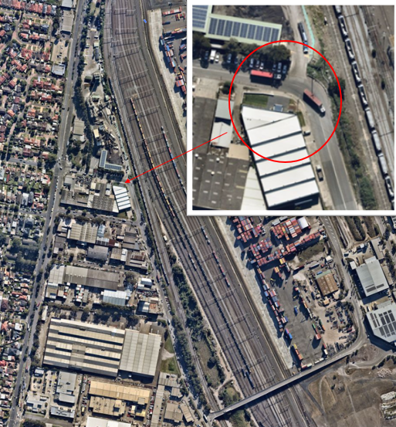

**Appendix 2 – Flower Power DA**

**Appendix 3 Turnout Dr Modifications**

**Appendix 4: HSE – Safety Alert**

