ILC at Enfield – Road Transport Coordination Group (RTCG) No38
Date: | Thursday, 9 June 2022
Time: | 09:00 – 09:45am
Location: | Online - Webex
Invitees: | Chair – Steve Cowley (NSW Ports)  Jonathon Lafforgue (NSW Ports)  Mark Goodall (NSW Ports)  Wayne Ashton (NSW Ports)  Bryan Beudeker (NSW Ports)  Hamish Wood (NSW Ports)  Peter Ushemasimba (NSW Ports)  Claudia Martinovic (BSMS Security)  Geoff DeSantis (Swift Transport)  Eshoo Dirou (LINX)  Milton Macfarlane (Northside Foods)
Apologies: | Frank Andriano - LINX, Michael Vokonakis - Swift Transport, Gordon Malesevic (Strathfield Council), Tommy Kwak – GOMAPS, Rory Gage - DCE Global, Jason Hwang - Shin Mi, Michael Dicembre - Northside Fine Foods, Eugene Quigley – Spandex, Dominic Crinnion – DPE, Jarrad Cayzer - NSW Ports, Paul McFadden – Mapei, Kathy Hackenberg – Harris Farm, Shaun Carpenter – Marinucci, David Lovegrove – Progress Rail
- Action Items From Previous Minutes
item | responsible party | action | Status | comments
1.1 | NSW Ports | NSW Ports to continue to engage with Traffic Engineers in response to concerns about road width for B-Double & Super B-Doubles to turn safely on the corner of Norfolk and Wentworth St.  (Appendix 1) | NSW Ports to provide update at next meeting. | (HW) to engage with consultants  (SC) To continue to engage traffic engineer John Ingles from Strathfield Council.  (SC) has provided (GS) with Ingles’ contact details. Ingles to assist with issue of cars parking and has supplied his direct number to ensure those who illegally park are fined by Parking Rangers.

- Infrastructure Update
  - Precinct A, Precinct E and Precinct H update
(MG) No new plans at either precinct. Precinct A and precinct E remain undeveloped, although there has been high activity relating to vegetation work. Furthermore, no traffic issues which have had a major impact on operations to report,
- Operations Update
  - LINX Intermodal Terminal (ED)
Increased export volumes, alongside the acquisition of extra windows at the ports. Besides that, business is operating as per usual with no issues to raise.
Change in Traffic Management Plan, relating to Gate T8 exit onto Mainline Drive no longer being in operation. All traffic now entering and exiting through the main terminal to avoid vehicles turning left and vehicles exceeding the 19m turning circle when turning right.
(SC) Gate T8 must still be accessible as an emergency exit for sub-tenants. (ED) to ensure assessment of Gate T8’s functionality occurs on next site inspection.
  - Swift Transport (GDS)
Business starting to increase, no operational issues to report.
Issue of trucks exiting the IMT, then proceeding to do U-turns at the entrance of the IMT has been addressed with Swift drivers. (ED) To communicate to (GS) if issue persists.
  - Spandex
No representative in attendance.
  - Northside Fine Foods (MM)
Expectedly business is slower than usual at this time of the year. Capitalising on this opportunity to conduct overdue maintenance.
Shortage of staff parking is anticipated within the next 1-2 months due to an increase of casual labour. Northside Fine Foods to review this issue internally.
  - GOMAPS
No representative in attendance.
  - DCE Global
No representative in attendance.
  - Shin Mi
No representative in attendance.
  - Mapei
No representative in attendance.
  - Harris Farm (Oli)
Nothing to report.
Actively attempting to resolves cleanliness issues raised by (MG)
  - Marinucci
No Representative in attendance.
  - Operational Interfaces
- New business
  - (SC) Reclassification Norfolk, Wentworth, and Cosgrove Roads from Local Council Roads to Regional Roads
The Future Transport 2056 Report established in February 2019, proposes adjustments to the road classification policy framework, and an update of the road network to align with the Hub and Spoke Transport Network Model. The application for reclassification from local council roads to regional roads submitted by The Strathfield Council in February 2022 will allow them to receive funding from the State Government for the maintenance and servicing of these roads.

  - (SC) Unauthorised parking of vehicles outside the terminals/tenanted areas
Vehicles are parking at the thatched area on Mainline Drive to complete paperwork. (SC) Call to action for tenants to educate their drivers to ensure all paperwork is completed and to know where their next destination is before they leave the terminal/facility. (ED) states LINX have already been communicating this issue to Vehicle operators when exiting their terminal.
(CM) drivers are compliant but issue still occurs daily. (BB) Tenants must communicate clearly to vehicle operators exiting their facilities that these areas are ‘No Stopping’ zones, which are different to ‘No Parking’.

  - (SC) Engagement with Auburn Police
The engagement with Auburn Police over the last 2-3 months has facilitated the implementation of a range of reckless driving prevention strategies around the precinct, whilst also improving internal reporting to assist with police investigations. The compliance of Auburn Police, alongside the application of Transport NSW license plate recognition cameras has thoroughly assisted the process of investigating dangerous driving in the precinct, particularly the many reports relating to burnouts.

  - (SC) Update on traffic observations within the precinct
These are observations that have been identified by the precinct Security provider (BSMS) in total for the period April to June, we recorded a total of 153 traffic observations.
- 45 Speeding observations – (CM) most likely staff members entering and exiting the precinct
- 39 were illegal manoeuvres
- 25 unauthorised parking/stopping events.
- 2 Burnout observations
- 1 Queuing
Major improvements in burnouts and queueing. Majority of illegal manoeuvres reported were Swift drivers engaging in illegal U-turns outside of the IMT. Now that issue has been addressed, a decrease in illegal manoeuvre observation is expected.

  - (MG) Ignoring Road signs at Delec Lane.
Line marking operations began 8-June. The works conducted include the installation of chevrons, painting of arrows on the roads, solid yellow lines around the precinct to indicate no stopping, lines being repainted, and the duplication of speed limit warnings on the roads in big lettering. Most works are expected to be completed over the long weekend with expected completion hoped by the week ending June 17th. (Appendix 2)

  - (JL) Blockade Australia – Protest Action
Blockade Australia protests are returning to Sydney between the 27th of June to the 2nd of July. Although an attack on Enfield may have a low chance of occurring, it is still crucial for tenants to review security plans, access control into facilities, and maintain a high level of vigilance throughout this time. Communication with security and emergency services is key to ensure the operation of the Enfield IMT is unharmed.

- Next meeting
Wednesday 21st September 2022

Appendix 1 – Norfolk Rd and Wentworth St

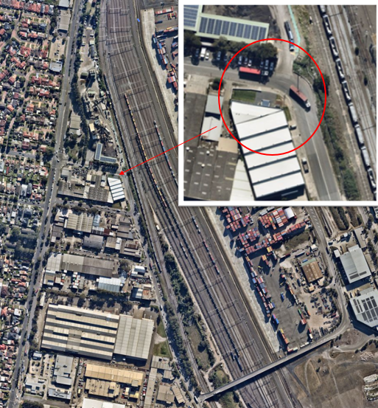

Appendix 2: HSE – Safety Alert
